TYPE THE TITLE OF THE PAPER USING TIMES NEW ROMAN FONT (SIZE 14 BOLD) AND DO NOT EXCEED TWO LINES

Author Name in Font Size 12¹, Corresponding Author^{2*}, and Author ³
¹ Mention the Department, Institute/University Name, City, Country in Font 11 Italic style
² Mention the Department, Institute/University Name, City, Country in Font 11 Italic style
³ Mention the Department, Institute/University Name, City, Country in Font 11 Italic style
*Corresponding_author@mail.com

Authors are requested to adhere to the format as per this document for the extended abstract submission. MS Word or Latex can be used following the format, and the file converted into pdf format needs to be submitted online. Type the extended abstract using font size 12, not exceeding 300 words. All the fonts used in the extended abstract must be Times Roman. Give a brief introduction, the methodology followed, results and discussion in brief in the abstract without giving subheadings and in the flowing text as one paragraph. If required, include at least one figure showing the key results and maximum two images are permitted in the abstract. The images must correspond to the main contribution of the research paper. Use high-quality images suitable for reprinting. No need to mention the references or bibliography in the abstract. The authors need to check the plagiarisms, and if found later, the paper will be removed from the conference. Only the authors of accepted abstracts will be requested to submit the full research paper. The abstracts prepared according to this format containing the original, unpublished work will be considered for the next stage after reviewing by experts. The full will also be reviewed before approval. At the time of submission, authors are requested to mention the broad sub-area/session. Some abstracts will be considered for the poster presentation by the organizers and in that case, full paper may not be needed. Selected full papers will be considered for the Scopus indexed journals (special issues and proceedings) based on the additional review as per the publisher requirement.
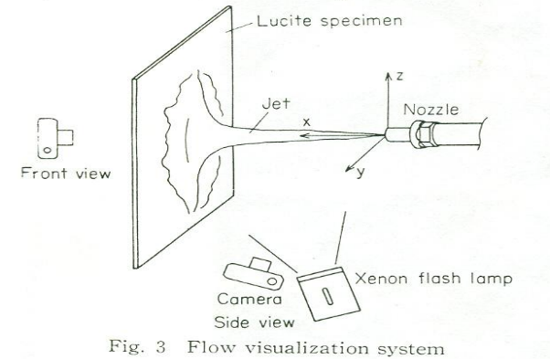

Fig. 1 Process description use font size 10 Fig. 2 Performance of the process developed

